## Architectural Overview

The Maker Den architecture can be viewed at two levels.

At a high level, devices stream data to the Azure “Devices” Event Hub. In turn, Stream Analytics consolidates and summarises the data back to the Devices Event Hub for visualisation purposes and generates alerts based on predefined thresholds.

Both the Devices and Alerts queues push data to the Connect the Dots service (using SignalR) for display on the dashboard.

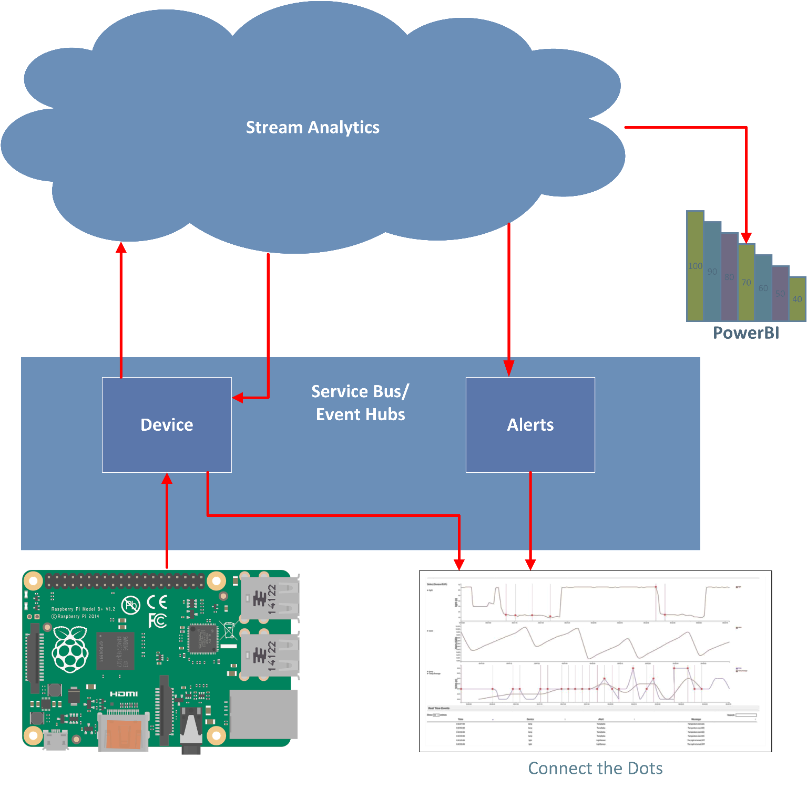

At a lower level, the Maker Den framework sits on top of the Universal Windows Platform. There’s a communications layer and a Actuator and Sensor command and control base class on top of which actuator and sensor base classes are built.

On top of the actuator and sensor base classes, the framework implements concrete classes for specific actuators (things that do something like move a servo or flash a light) and sensors (things that measure and report readings like temperature, light level, sound, pH, and so on).

Finally, the Maker Den application code takes advantage of this framework to interact with the physical world.

